TASKS’
- In Active Directory Users and Computers, create a new Organizational Unit (OU) called 'EventPlanners' to represent a team that manages college fests like those seen in BookMyShow.
➢
Step 1: Open ADUC
Press Win + R, type dsa.msc, and press Enter to open Active Directory Users and Computers.

Step 2: Select the Domain
Expand the domain anant.local in the left pane.

Step 3: Create a New OU
Right-click the domain anant.local, select New → Organizational Unit.

Step 4: Enter the OU Name
Type EventPlanners in the Name field. Keep the option to protect the container from accidental deletion selected, then click OK.

Step 5: Verify the OU
Confirm that EventPlanners appears under the domain in Active Directory Users and Computers.

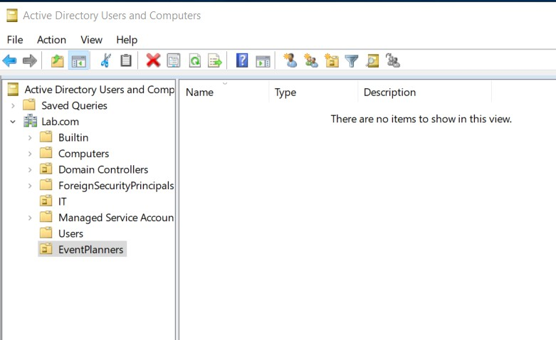

- Add three user accounts to the 'EventPlanners' OU with usernames inspired by your favorite IPL cricket players (e.g., viratk, msdhoni, hardikp). Set a strong password for each and ensure 'User must change password at next logon' is enabled.
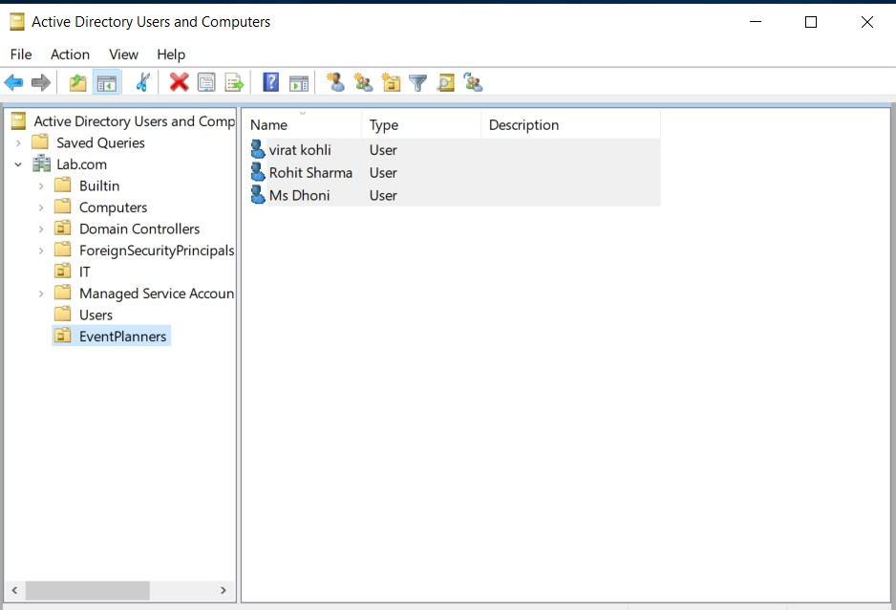
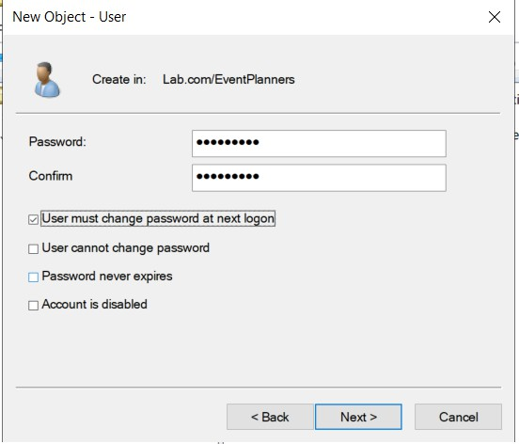
➢

- Create a security group named 'FestTicketManagers' inside the 'EventPlanners' OU. Add all three user accounts you created to this group.
➢
Step 1: Open ADUC
Press Win + R, type dsa.msc, and press Enter.

Step 2: Select the EventPlanners OU
Expand the anant.local domain and locate the EventPlanners OU.

Step 3: Create the Security Group
Right-click EventPlanners, select New → Group, and enter FestTicketManagers as the group name.

Step 4: Configure Group Properties
Select Global as the group scope and Security as the group type. Click OK to create the group.

Step 5: Add the Three Users
Right-click FestTicketManagers and select Properties. Open the Members tab and click Add.

Step 6: Select User Accounts
Enter viratk, msdhoni, and hardikp. Click Check Names and then OK to add the users.

Step 7: Verify Membership
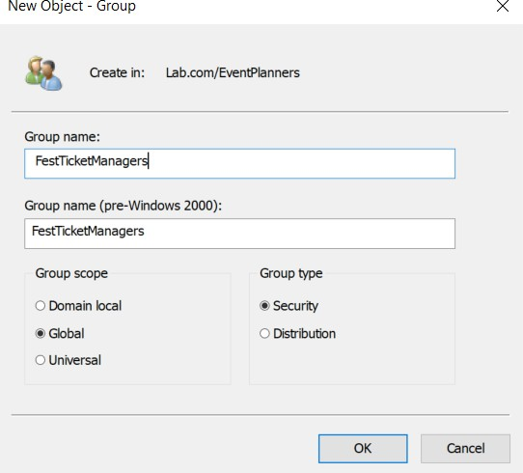
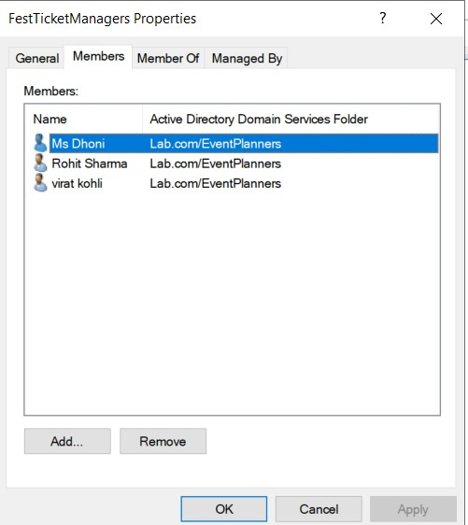
Open the group's Properties and check the Members tab to confirm that all three accounts are listed.

- Rename one of your user accounts in the 'EventPlanners' OU to match your own first name and update their description field to 'Social Media Manager for College Fest'.
➢
